Aircraft Cabin Cleaning Van

Purpose
This vehicle has been designed in order to transport cleaning groups of 4-7 persons with their equipment to the aeroplanes. This vehicle combines maximum storage and optimal accessibility with a vehicle with small outside dimensions and optimal manoeuvrability.

Specifications:
Basic vehicle: VW Crafter or Mercedes Sprinter short wheelbase , , or basic vehicle to customers choice with 2 sliding doors, rear doorstep, sliding window in RH door, leatherette seat covering and 3 seats in the front.

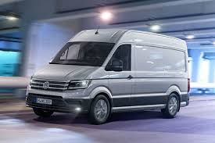

Interrior dessign

Equipment options

- Electronic speed limiter.
80 litres isolated water tank for the storage of hot water, this water can be taken form the rear
via a tap over a poly-urethane sink.
- Interior light 4 x 16 Watt TL’s , 1 in the passenger compartment, 1 in the waste
compartment and 2 in the passenger compartment.
- All metal structures inside the vehicle are made out of zinc plated, powder coated steel.
- All wooden panels are made out of water resistant multi-layer tropical wood, painted grey.
- All seats are covered in grey leatherette.

Rear compartment houses:

- A vacuum cleaner and its lead, 19 storage containers for safety-instructions, headrest covers,
airline magazines, cleaning towels, coat-hangers etc., 2 floor brushes and a bucket
- 1 100% watertight poly-urethane sink
- The car is equipped with a double floor and from the rear side of the vehicle a ladder can be
slid underneath it, this ladder serves under more for the cleaning of the cockpit windows.

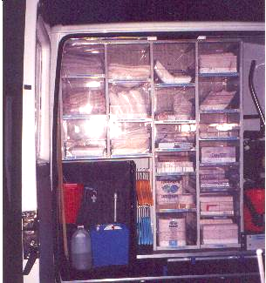

LH compartment
- At the LH sliding door there is a waste compartment which is 100% separated from the other
compartments, this compartment is equipped with a 100% watertight liner and has a surface
of 0.8*1.4 m, the entrance has a variable height of 0.35-0.7 m, the compartment is dividable
in two in order to separate paper and other waste. The top of this compartment is equipped
with is a storage net.

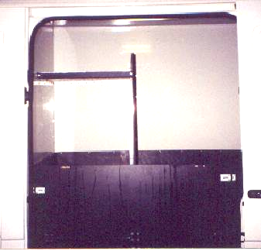

RH compartment
- The passenger compartment is located at the RH sliding door and is equipped with 2 seats
(2m and 0.4 m) with 5 storage partitions, attainable via the bottom supported by gas-springs.
- One of the partitions is equipped with a 12 Volts cooling box, its supply is limited by a
timer in order to save the battery.
- 1 additional sliding window (0.44*0.53 m) and an isolated roof .

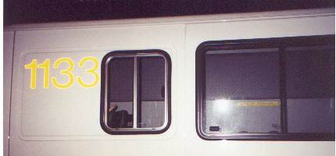

Options
* Roofrack * Air conditioning/heating
* Working lights * Hot water by diesel heater

